**

**Digital Elevation Model (DEM) 5 Metre Grid of Australia derived from LiDAR**

**Metadata Statement**

Last updated in 2015

*Geocat Number: 89644*

**Use Constraint:**



© Commonwealth of Australia (Geoscience Australia) 2015

This material is released under the [**Creative Commons Attribution 4.0 Australia**](https://creativecommons.org/licenses/by/4.0/)Licence**.**

**Keywords:**

Physical Geography, Elevation, DEM , ECOLOGY Landscape, LAND Topography Models

**Definition:**

Digital Elevation Model (DEM) 5 Metre Grid of Australia derived from LiDAR

**Abstract:**

The LiDAR-Derived 5 Metre Digital Elevation Model Version 1.0 represents a National 5 metre (bare earth) DEM which has been derived from some 236 individual LiDAR surveys between 2001 and 2015 covering an area in excess of 245,000 square kilometres. These surveys cover Australia’s populated coastal zone; floodplain surveys within the Murray Darling Basin, and individual surveys of major and minor population centres. All available 1 metre resolution LiDAR-derived DEMs have been compiled and resampled to 5 metre resolution datasets for each survey area, and then merged into a single dataset for each State. These State datasets have also been merged into a 1 second resolution national dataset.

The acquisition of the individual LiDAR surveys and derivation of the 5m product has been part of a long-term collaboration between Geoscience Australia, the Cooperative Research Centre for Spatial Information (CRCSI), the Departments of Climate Change and Environment, State and Territory jurisdictions, Local Government and the Murray Darling Basin Authority under the auspices of the National Elevation Data Framework and Coastal and Urban DEM Program. The source datasets have been captured to standards that are generally consistent with the Australian ICSM LiDAR Acquisition Specifications with require a fundamental vertical accuracy of at least 0.30m (95% confidence) and horizontal accuracy of at least 0.80m (95% confidence).

**DEM_5_metre:**

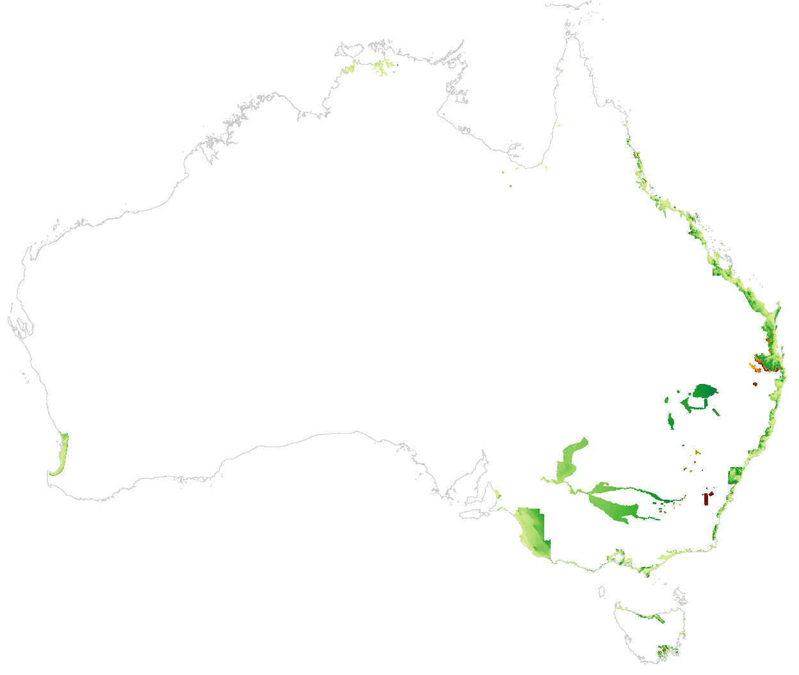

**Lineage Statement:**

The LiDAR-Derived 5 Metre Digital Elevation Model Version 1.0 represents a National 5 metre (bare earth) DEM which has been derived from some 236 individual LiDAR surveys between 2001 and 2015 covering. All available 1 metre resolution LiDAR-derived DEMs have been compiled and resampled to 5 metre resolution datasets for each survey area, and then merged into a single dataset for each State. These State datasets have also been merged into a 1 second resolution national dataset.

The source datasets have been captured to standards that are generally consistent with the Australian ICSM LiDAR Acquisition Specifications with require a fundamental vertical accuracy of at least 0.30m (95% confidence) and horizontal accuracy of at least 0.80m (95% confidence).

All 1-metre DEMs were resampled to 5-metre-resolution using a neighbourhood-mean method for analysis. Error surfaces were created along with the DEMs by calculating the difference with the National DEM.

**Source Information:**

Jurisdictional data:

**Commonwealth - Geoscience Australia/Murray Darling Basin Authority**

BrokenHill2009

Chowilla2003

Coorong2008

Edward2013_z54

Edward2013_z55

Euston2007

Gwydir2008

Gwydir2013

Hattah_Kulkyne2004

Hattah2006

Katarapko2007

LakeVictoria2003

Lindsay2004

lowerdarlinglidar_2013

MacquarieMarshes2008

Murrumbidgee2009

Namoi2013

NarranLakes2004

Pyap2008

SouthernMDB2001

WaggaWagga2009

Walpolla2004

WestLakeVictoria2007

Wetherall2002

DarlingBourke2009

**New South Wales - NSW Department Land and Property Information/NSWOEH**

AdelongTown0112

Ballina0610

BatemansBay0611

Bega0313_z55

Bega0313_z56

BlayneyTown0209

BrokenHill2009

BrokenHill2009

BrokenHillTown1112

Bulahdelah0613

ByronBay0810

CanowindraTown0711

Chowilla2003

CoffsHarbour0913

CollarenebriTown1012

CollectorTown0209

Coraki0810

CrookwellTown0209

CulcairnTown0212

DarlingBourke2009

Dunoon0610

Edward2013_z54

Edward2013_z55

EugowraTown0811

Euston2007

Forster0812

GeurieTown1009

GoulburnTown0711

Grafton0310

GunningTown0209

Gwydir2008

Gwydir2013

Hattah_Kulkyne2004

Hattah2006

HawkesburyNORTH0511

HawkesburySOUTH0511

HayTown0912

HentyTown0212

HolbrookTown0212

HumulaTown0112

HunterCoast2007

JerilderieTown0713

Kempsey1109

Kiama0311

Kurnell2008

LakeGeorgeBasin2014

LightningRidgeTown1012

Lindsay2004

Lismore0610

LockhartTown0212

lowerdarlinglidar_2013

MacquarieMarshes2008

MangoplahTown0112

Merimbula0313

MolongTown0811

Murrumbidgee2009

Nambucca1209

Namoi2013

NarranLakes2004

NarromineTown0511

NepeanRiverEAST0311

NepeanRiverWEST0211

Nowra1210

PortMacquarie0512

PortStephens1212

RaymondTerrace0613

SouthernMDB2001

Sydney2008

SydneyNorth0413

SydneySouth0413

TaralgaTown0209

Taree0812

Tenterfield0609

TheRockTown0112

TweedHeads0314

Ulladulla0511

WaggaWagga2009

Walpolla2004

Wellington1009

WestLakeVictoria2007

Wollongong0413

Wooli0410

Yamba0410

YeovalTown1009

**Victoria - Victorian Department of Environment, Land, Water and Planning**

EastGippsland2008

NintyMileBeach2008

PortPhillip_Westernport2007

SouthGippsland2008

SouthWest2007

WestGippsland2008

**South Australia - South Australia Department for Environment, Water and Natural Resources**

Adelaide2009

AdelaideLiDAR_2013

SA_Coastal_LiDAR (VictorHarbour and North Adelaide)

SERIC2007

**Queensland - Queensland Department of National Resources and Mines**

AurukunCouncil2006

BrisbaneCityCouncil2009

Bundaberg2010

BundabergCouncil2009

BundabergCouncil2011

BundabergCouncilCCP2010

BurdekinCouncil2009

BurdekinCouncil2010

BurdekinRegionalCouncil2011

Burketown2010

BurketownToCoast2010

Cairns_Council_2010

CairnsCouncil2009

CairnsCouncil2010

CassowaryCoastCouncil2009

CassowaryCoastCouncil2010

CassowaryCoastRegionalCouncil2010

CookCouncil2009

DoomadgeeCouncil2010

FraserCoast2010

GladstoneRegionalCounci2009

GladstoneRegionalCouncil2010

GoldCoastCityCouncil2009

GregoryDowns2010

Gympie2010

HinchinbrookCouncil2009

HinchinbrookCouncil2010

HopevaleCouncil2009

IpswichCityCouncil2009

IsaacCouncil2009

IsaacCouncilCCP2010

IsaacCouncilTCP2010

KowanyamaCouncil2010

LockhartRiverCouncil2006

LockyerValley2010

LockyerValleyCouncil2011

LoganCityCouncil_2008

MackayCouncil2009

MackayCouncil2010

MapoonCouncil2006

MoretonBay2009

MorningtonCouncil2006

NapranumCouncil2006

NormantonToKaurumba2010

NorthernPeninsulaAreaCouncil2006

PalmIslandCouncil2010

PormpuraawCouncil2006

RedlandCityCouncil2009

RockhamptonCouncil2008

RockhamptonCouncil2009

RockhamptonCouncilCCP_2010

RockhamptonCouncilTCP_2010

ScenicRimCouncil2011

SomersetRegionalCouncil2009

SomersetRegionalCouncil2011

SouthernDownsCouncil2010

SunshineCoast2009

TablelandsRegionalCouncil2011

ToowoombaCouncil2010

ToowoombaCouncil2011

Torres_Strait_Island_Regional_Council2010_MabuiagIsland

Torres_Strait_Island_Regional_Council2010_SueIsland

Torres_Strait_Island_Regional_Council2010_WednesdayIsland

Torres_Strait_Island_Regional_Council2010_YamIsland

TownsvilleCityCouncilLowerBurdekin2011

TownsvilleCouncil2009

TownsvilleCouncil2010

TownsvilleCouncil2011

Weipa2010

WhitsundayCouncil2009

WhitsundayCouncil2010

WhitsundayCouncilMackayProject2009

WujulWujulCouncil2009

YarrabahCouncil2009

YarrabahCouncil2010

YarrabahShireCouncil2010

**Tasmania - Tasmanian Department of Primary Industries, Parks, Water and Environment**

Dataset Supplied and available through Geoscience Australia

AdventureBay2014

AnsonsBay2014

ArthurRiver2014

Beechford2014

Bicheno2014

Bridport2014

Brighton2014

BurnieDevonportLaunceston2013

CoalMines2014

Currie2014 (aka KingIsland2014)

Dover2014

Fallmouth2014

GranvilleHarbour2014

GreaterHobart2013

HuonRiverValley2013

Kettering2014

LadyBarron2014

MtWellingtonRiverDerwent2010

Murdunna2014

MusselroeBay2014

PortArthur-1-2014

PortArthur-2-2014

PremaydenaNubeena2014

SaltWaterRiver2014

SouthPort2014

StHelens2008

Strahan2014

Swansea2008

Swansea2014

Tomahawk2014

Triabunna2014

TrialHarbour2014

Weymouth2014

Whitemark2014 (aka Flinders Island)

**Western Australia – WA Department of Water/ Landgate / WA Department of Transport and Regional Development**

ALS_Exmouth_Flood_Study

Bunbury2008

Busselton2008

Harvey2008

Peel2008

Perth2008

**Northern Territory Department of Lands and Planning**

Darwin2009

Kakadu2011

**Positional (Spatial Confidence) Accuracy:**

Fundamental spatial accuracy of the individual survey must conform to the following ICSM LiDAR Specification standard:

a.Fundamental Vertical Accuracy (FVA)

i.<= +/- 30cm. 95% confidence interval (1.96 x RMSE)

b.Fundamental Horizontal Accuracy (FHA)

i.<= +/- 80cm. 95% confidence interval (1.73 x RMSE)

Refer to ICSM Guidelines for Digital Elevation Data. Previous reporting of vertical accuracy has generally referred to FVA of <= +/- 15cm at the 68% confidence interval and FHA of <= +/- 45cm at the 68% confidence interval.

All 1-metre DEMs were resampled to 5-metre-resolution using a neighbourhood-mean method for analysis. Error surfaces were created comparing the 5m DEMs with the NationalDEM (25m Product).

All 1-metre DEMs were resampled to 5-metre-resolution using a neighbourhood-mean method for analysis. Error surfaces were created along with the DEMs by calculating the difference with the National DEM (25m Product). The results are shown in the table below:

|  |  |  |  |  |  |
| --- | --- | --- | --- | --- | --- |
| **5mDEM/NationalDEM Difference Surface Analysis** | | | | | |
| *(State 5m Mosaic minus NationalDEM)* | | | | | |
|  | Min. | Max. | Range | Average | Std. Dev. |
| NSW | -418.072 | 157.1255 | 575.1973 | -0.53633 | 2.877623 |
| QLD | -382.306 | 197.5566 | 579.8631 | -0.20121 | 2.895224 |
| VIC | -133.677 | 85.97665 | 219.6539 | -0.27768 | 1.901184 |
| WA | -42.3063 | 24.09048 | 66.39675 | -0.05118 | 0.913017 |
| SA | -63.022 | 31.96379 | 94.98576 | -0.51867 | 1.461576 |
| TAS | -184.689 | 514.0353 | 698.7246 | -0.38168 | 3.028206 |
| NT | -77.6439 | 57.59478 | 135.2387 | -0.29389 | 1.097502 |

**Logical Consistency:**

Geoscience Australia used a Validation and Testing methodology to ensure the quality and compliance of the elevation datasets.

Testing is carried out using a mixture of computer programs and proprietary GIS packages (such as ArcGIS; LP360 and LASTools). Many of the tests are automated, using customised computer programs. These are supported by a detailed on-screen visual inspection of the digital data against available imagery and reference material for logical consistency and attribute accuracy.

**Completeness:**

Data coverage of the National_DEM_5_metre exists where LiDAR data has been acquired and meets the Australian ICSM LiDAR Acquisition Specifications. Over 220 individual LiDAR surveys covering approximately 245,000 Km² have been acquired between 2001 and 2015

**Data Dictionary:**

NA

**Data Maintenance:**

The next revision of this database will be determined by Geoscience Australia’s work program. Currently, there is no set timeframe; this is also dependent upon available information from the Jurisdictions.

**Known Limitations of the Data:**

Known issues with:

* Hydro flattening
* Erroneous interpolation in the DEM around the edges of the AOIs

The data covers the land mass of Australia, that is:

* West bounding longitude 112.8o
* East bounding longitude 154.1o
* South bounding latitude -44o
* North bounding latitude -8.9o

**Revision Dates and Descriptions:**

|  |  |
| --- | --- |
| Date | Descriptions |
| Dec 2015 | Initial spatial data and associated metadata document created and released |
|  |  |

**Data Contact:**

Using this email address: [elevation@ga.gov.au](mailto:elevation@ga.gov.au)

Please address your correspondence to:

1. Team Leader – Elevation Section, National Location Information Group, Geoscience Australia